

# **Automation & Robotics**

# **Life Skills for Professionals**

# **(AEC 012)**

**SUBMIITED BY:**

**BIRENDRA KUMAR**

**SUBMIITED TO:**

**MR. RISHI SEN GUPTA**

**ROLL NUMBER: 2301010288**

**COURSE: BTECH CSE CORE**

**SECTION: E**

**School of Engineering & Technology**

**K. R. MANGALAM UNIVERSITY**

**Sohna, Haryana 122103, India**

**Introduction**

**Project Objective**

Many have predicted the roboticisation of society since **Czech dramatist Carel Capek** introduced the world to the word and concept ‘robot’ in his influential **1921** play RUR – **Rossum’s Universal Robot (O’Connell 2017, pp. 104-107)**. These have been most prevalent in fields that require routine task fulfilment, such as agriculture and manufacturing, as in the car-making industry; in retailing and distribution, as in warehouses and self-service cashiers; in the military, as in drone technology; and in the mundane but significant world of **“back office automation”** (**Willcocks** and **Lacity 2016**). Many analysts, commentators and artists have foregrounded the related social, political and ethical issues (**Amos and Page 2014**; **Dyer-Witheford** 2015; Susskind and Susskind 2015; Avent 2016; Carr 2016; Eurofound 2016; Willcocks and Lacity 2016; Bell, 2017; Cameron 2017; Case 2017; Kiggins 2018). The objective of this project is to explore, design, and implement innovative robotic systems and automation techniques aimed at enhancing efficiency, accuracy, and productivity across various domains.

**1. Exploring the Integration of Robotics in Real-world Applications**

One of the core objectives of this project is to investigate how robotics can be effectively integrated into real-world scenarios. This involves identifying current challenges in sectors such as manufacturing, healthcare, agriculture, defense, and household environments where robots can significantly improve outcomes. The project aims to propose robotic solutions that reduce human workload, increase precision, and operate in hazardous or inaccessible environments, thereby minimizing risks to human life.

For example, in manufacturing, robotic arms can take over repetitive and physically demanding tasks, ensuring consistency and reducing fatigue-related errors. In agriculture, autonomous robots can assist with tasks like seeding, weeding, and harvesting, thereby addressing labor shortages and enhancing crop yields. Each of these use-cases demonstrates the potential of robotics to transform traditional practices.

**2. Enhancing Automation for Improved Efficiency**

While robotics deals with the physical construction and control of machines, automation encompasses the logic and decision-making that drives those machines. This project focuses on integrating smart automation with robotic systems, enabling them to function autonomously or with minimal human intervention. By incorporating technologies such as Artificial Intelligence (AI), Machine Learning (ML), and Internet of Things (IoT), the project aims to create intelligent systems capable of adapting to dynamic environments.

The objective here is not just to automate tasks but to make the process intelligent — for example, a warehouse robot that can dynamically plan the most efficient route based on real-time inventory data, or a healthcare robot that adapts its assistance based on a patient's changing physical state. This kind of “thinking automation” increases system responsiveness and enhances the overall quality of operations.

**3. Promoting Cost-effective and Scalable Robotic Solutions**

Another key goal of the project is to design robotic and automation systems that are **cost-effective and scalable**. One of the current limitations in widespread robotic adoption is the high initial investment and complexity of implementation. This project aims to develop modular and user-friendly systems that can be easily adapted for small and medium-sized enterprises (SMEs) and even educational purposes.

This objective pushes for innovation not only in technical performance but also in affordability, usability, and maintainability. Open-source hardware and software frameworks are explored as part of the strategy to lower barriers to entry and encourage community-driven enhancements.

**Project Background**

Experts believe that the "industrial revolution" will change the whole world, not just the principle of production. In this case we are talking about the **fourth industrial revolution**, or as it is called - **Industry 4.0**. If you do not go into the controversy of specialists, you can follow the opinion of Klaus Schwab [1], who divided the industrial revolution into **four main trends**: **unmanned vehicles**, **3D printing**, **advanced robotics** and **new materials**. In the paper we will focus on advanced robotics.

If we look at the history of the robotics development, we can observe that the increase of the functionality of robots causes the raise of the number of their possible applications in various fields of human activity. The creation of a robot was preceded by the idea of replacing a person in hard work, and the physical capabilities of the human body served as a model for them. The robot can be represented as a universal machine for performing mechanical actions. The functional diagram of the robot includes the executive system, the sensor system, the control device and the external environment.

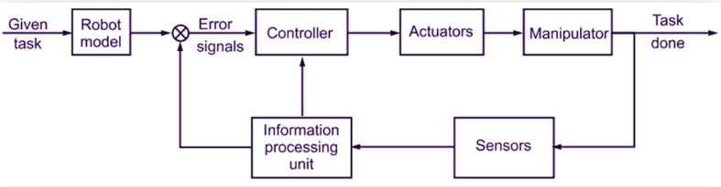

Fig 1 The Functional diagram of Robot

Today, robots go beyond their limits and become flexible, mobile, and more intelligent. As part of Industry 4.0, robots have become the driving force of automation where it has never been before. Compared with pre-revolutionary production systems, where the human operator and robotic complexes are separated according to safety standards, production using advanced robotics and a collaborative system of human interaction — the operator and robot work together in a single working environment [2]. In the future, automation of processes in the field of logistics, health and utilities will be carried out by robotic systems.

The main field of application of robotics is industry. Technologies contributing to the improvement and automation of processes have changed. Progress in the field of robot sensors has made robots compact and more susceptible to the environment expanding the range of their tasks. Such robots are called **collaborative robots**. This type of robots is determined by compliance with the technical specification of the **ISO/TS 15066:2016** standard [3], in particular with safety measures when interacting with the robot.

This review deals with human-robot collaboration in an industrial context. Collaborative robots have become evidence of the emergence of a new generation of robots that will evolve with an orientation toward increasing interaction between humans and robots. At one Fanuc plant in Oshino, Japan, industrial robots produce industrial robots, supervised by a staff of only four workers per shift. In a Philips plant producing electric razors in the Netherlands, robots outnumber the nine production workers by more than 14 to 1. Camera maker Canon began phasing out human labor at several of its factories in 2013.

This “lights out” production concept—where manufacturing activities and material flows are handled entirely automatically— is becoming an increasingly common attribute of modern manufacturing. In part, the new wave of automation will be driven by the same things that first brought robotics and automation into the workplace: to free human workers from dirty, dull, or dangerous jobs; to improve quality by eliminating errors and reducing variability; and to cut manufacturing costs by replacing increasingly expensive people with ever-cheaper machines. Today’s most advanced automation systems have additional capabilities, however, enabling their use in environments that have not been suitable for automation up to now and allowing the capture of entirely new sources of value in manufacturing.

New developments in robotics and AI, and possible linked futures (utopian and dystopian), are regularly reported in fiction **(Amos and Page 2014)** and non-fiction sources. Print and social media articles reflect the diverse (potential or real) impacts of robots: in novel applications of the technology **(Knight 2015; Mollman 2015)**; in speculation about human-robot interaction (**Jozuka 2015; Kageyama 2015**); and in expression of fears of the societal impact of robotics technology (**Cellan-Jones 2015; Kelion 2015**). These attest to the increasing current and potential use and public awareness of robots, while also pointing to some of the fears and concerns.

**Project significance and relevance**

There is now the potential to provide a mix of human and technological applications to social care delivery and the technologisation of care is on the agenda for policy and practice. Technologies used in the administration, management and delivery of care may include Assistive Technologies (**ATs**) such as mobile technologies/apps or screen readers (**Wynne et al 2016**); and more sophisticated Assisted Living Technologies (ALTs) such as telecare and telehealth; smart homes; or social robots (**Wigfield et al, 2013; Centre for Policy on Ageing 2014; Dunn et al, 2014**). Dunn et al (2014) indicate that **95% of UK** social care providers use at least one digital technology in their organisation, most usually forstaff communication needs (now, likely to be smartphones). The use of AT is thus normal and routine, but reflection on its implications or potential is only beginning to emerge (**Hansen et al 2016**).

ALT encompasses caring technologies labelled ‘**telecare**’ or ‘**telehealth**’; and ‘**digital participation services**’ designed to enrich the lives of people in need of social support living at home, through education, entertainment or communication (see, for example, Konnektis.com). It also includes “**wellness services**” that aim to encourage people to adopt and maintain a healthy lifestyle, to prevent or delay the need for additional health or social care support (**Lewin et al 2010**). Such developments increasingly involve technology-based self-monitoring, leading to the emergence of what has been termed **“the quantified self**” (**Lupton 2016**), part of the broader adoption of **“metrics”** in contemporary society (**Beer 2016**).

1. **Falling robot prices**

As robot production has increased, costs have gone down. Over the past 30 years, the average robot price has fallen by half in real terms, and even further relative to labor costs (Exhibit 1). As demand from emerging economies encourages the production of robots to shift to lower-cost regions, they are likely to become cheaper still.

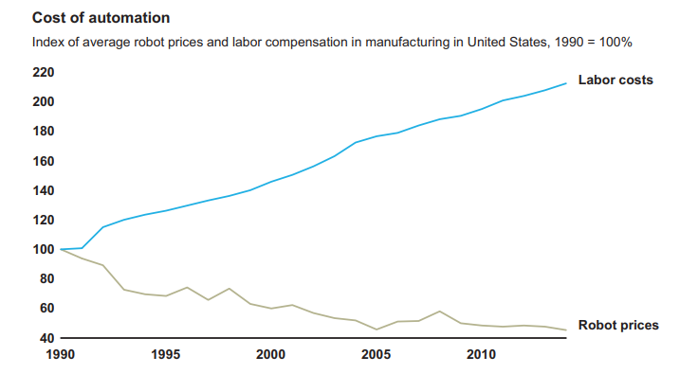

Fig 2. Robot prices have fallen in comparison with labour costs

1. **Accessible talent**

People with the skills required to design, install, operate, and maintain robotic production systems are becoming more widely available, too. Robotics engineers were once rare and expensive specialists. Today, these subjects are widely taught in schools and colleges around the world, either in dedicated courses or as part of more general education on manufacturing technologies or engineering design for manufacture. The availability of software, such as simulation packages and offline programming systems that can test robotic applications, has reduced engineering time and risk.

1. **Ease of integration**

Advances in computing power, software development techniques, and networking technologies have made assembling, installing, and maintaining robots faster and less costly than before. For example, while sensors and actuators once had to be individually connected to robot controllers with dedicated wiring through terminal racks, connectors, and junction boxes, they now use plug-and-play technologies in which components can be connected using simpler network wiring. The components will identify themselves automatically to the control system, greatly reducing setup time. These sensors and actuators can also monitor themselves and report their status to the control system, to aid process control and collect data for maintenance, and for continuous improvement and troubleshooting purposes

1. **New capabilities**

Robots are getting smarter, too. Where early robots blindly followed the same path, and later iterations used lasers or vision systems to detect the orientation of parts and materials, the latest generations of robots can integrate information from multiple sensors and adapt their movements in real time.

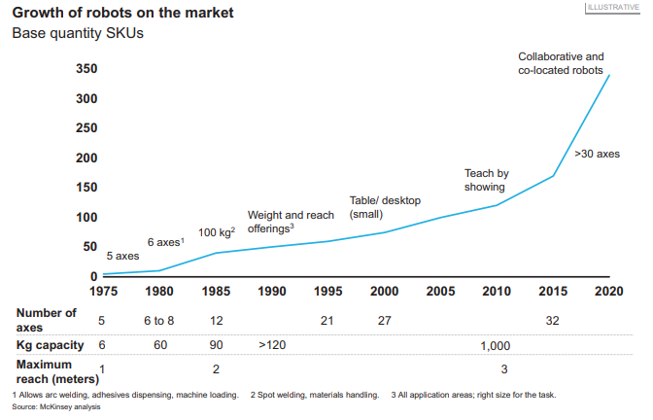

Fig 3. The increasing variety, size range, and capabilities of robots

**Literature Review**

**History of Robotics**

Industrial applications of Robotics gained a paramount importance in the last century. The beginning of “**Industrial Robotics**”, as we currently define it, can be dated back to the **1950’s**. In this paper, the main milestones of the history of industrial robotics, from its beginning (**in the 1950’s** and even earlier) to the end of the **20th century**, will be mentioned and described. The evolution of industrial robots can be subdivided in four categories, as in (**Zamalloa, 2017**), the first three covering the timespan from the **1950’s** to the end of the **1990’s.** The robots of the **fourth generation** (which ranges from **2000 to nowadays**), that are characterized by high-level “intelligent” features.

* **The First Generation of Industrial Robots (1950-1967)**

The **first generation** of industrial robot spans from **1950** to **1967**. The robots of this generation were basically programmable machines that did not have the ability to really control the modality of task execution; moreover, they had no communication with the external environment. With respect to the hardware, the first generation robots were provided with low-tech equipment, and servo-controllers were not present (**Wallen, 2008**).

The history of industrial robotics is conventionally set in the **1950’s**, although some developments in automation had taken place before: namely, a **“programmable”** paint-sprayer device invented by **Pollard** and **Roselund** in **1938 (Koetsier, 2019)**, and a tele-operated **“manipulator”** invented by **Goertz** in **1949,** for instance. However, the turning point for industrial robotics was due to the genius of **George Devol**, who designed in **1954** a “**Programmable Article** **Transfer**” (this was the name given when the patent request (Devol, 1954) was filed). Such a device was the base for the development of Unimate, that is considered the first **“true”** industrial robot in history.

**Devol** (Malone, 2011), who was basically a scientist, needed an entrepreneurial mate with whom set up in a more concrete way his idea of a robotic manipulator which could be used to automatize industrial processes. In **1954** he met **Joseph Engelberger**, an engineer employed in the spatial industry, and they agreed on setting up a company which could manufacture robots for industrial applications. This led to the foundation of a company named **Unimaton**, which produced in **1961** the **first Unimate robot** (Figure 4). Unimate, which was hydraulically actuated, was immediately installed in an automotive company, namely in the **General Motors factory** located in Trenton (New Jersey, USA), where it was employed to extract parts from a die-casting machine (as mentioned earlier, it was used for a single task, because it was very complicated to reprogram it). In the following years, several other Unimates were installed in automotive factories, where were mainly employed for spot-welding of cars and for handling of workpieces (**Wallen, 2008**).

In the same years, several robot manufacturing companies were born, due to the fact that many entrepreneurs understood that this kind of devices had great potentialities, especially in the automotive sector. Companies like **Ford** and **General Motors** started to consider the automatization of their productive plants and needed device such as the new robot to achieve this goal.

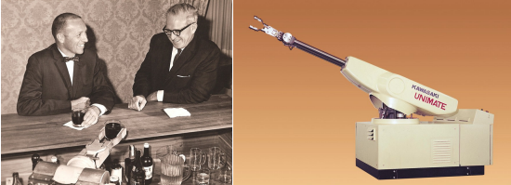

**Fig 4. Joseph Engelberger and George Devol (left); the Unimate robot (right)**.

One of such companies was, for instance, **AMF Corporation**: in **1962** they manufactured a new robot that was called **Versatran** (i.e. “**versatile transfer**”). It was a cylindrical robot (Figure 5) that was ordered by Ford for its production plants in **Canton** (Ohio, USA), thus enjoying a good popularity (**Birnie, 1974**). The **Versatran** was also the first robot to be installed in a productive site in **Japan (1967)**. In particular, this led to the development of the **Kawasaki-Unimate 2000**, the first industrial robot ever built in Japan.

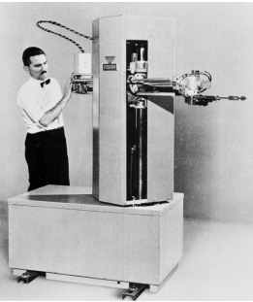

**Fig 5. The Versatran robot**

* **The Second Generation of Industrial Robots (1968-1977)**

The industrial robots of the second generation (conventionally ranging from **1968 to 1977**) were basic programmable machines with limited possibilities of self-adaptive behavior and elementary capabilities to recognize the external environment (**Zamalloa, 2017**). These robots used servo-controllers, which enabled them to perform both point-to-point motion, and continuous paths as well. Their control system consisted of microprocessors or of **Programmable Logic Controllers** (PLC), and they could be also programmed by an operator by means of a teach box.

At the beginning of the history of industrial robotics, the robots had **hydraulic actuators**. The shift from hydraulic to electric actuators took place in the **1970’s**, when the electronic components needed to govern a robot reached the full technical maturity. As a matter of fact, microprocessors and other components started to be widely used at that time: this allowed the robot manufacturers to dispose of powerful and cost-effective devices which could be employed to implement control systems able to deal with a complex and computationally expensive task such as the control of a robot.

From the scientific point of view, a significant base for the development of electrically driven robots was the merit of **Victor Scheinman** (**Scheinman, 1973**). Scheinman was a mechanical engineering student at **Stanford University** who in **1969** designed and built the famous **Stanford Arm** (Figure 6). This robot was the first prototype of a robot actuated by electric motors (6 DC motors) and controlled by a **PDP-6** microprocessor. The Stanford Arm had 5 revolute and one prismatic joint, for a total of 6 DOFs, and its kinematic chain was made of harmonic drives and spur gear reducers. Its inverse kinematics could be analytically solved in a closed form, which allowed a fast trajectory execution. Moreover, some sensors (tachometers and potentiometers) were mounted on the robot, in order to measure position and velocity of the robot joints.

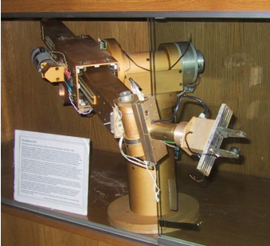

**Fig 6. The Stanford Arm**

Four years later (**1973**), Scheinman designed another electrical robot, named **Vicarm**, that was smaller and lighter than the industrial robots of that time. This made Vicarm particularly suitable for use in tasks, such as assembly of parts, where the robot was not required to lift and carry heavy loads. These features of Vicarm were so appreciated, that **Unimation** bought the company that produced Vicarm and exploited its know-how to design and manufacture (in **1978**) the famous **PUMA** robot.

In **1974**, the Swedish company **ASEA** (now ABB) started the production of the robots of the famous and successful **IRB series**, well known worldwide also for their typical orange color. The first robot of this series, that was issued for more than 20 years, was the **IRB-6**, which was largely employed in productive sites for complex tasks (machining, arc-welding), for its ability to move smoothly along continuous paths.

* **The Third Generation of Industrial Robots (1978-1999)**

The industrial robots of the third generation (conventionally ranging from 1978 to 1999) were characterized by a larger extent of interaction with both the operator and the environment, through some kind of complex interfaces (such as vision or voice). They also had some self-programming capabilities, and could reprogram themselves, although by a little amount, in order to execute different tasks (Zamalloa, 2017). These robots were provided with servo controls, and could execute complex tasks, by moving either from point to point or along continuous paths. The possibility of high-level, off-line programming enlarged the operational potential of the robots: for in-stance, they could elaborate data from sensor reading, in order to adjust the robot movements taking into account changes in the environment (e.g. changes inposition and orientation of the workpieces).

Between the end of the 1970’s and the beginning of the 1980’s, other scientific and technical improvements contributed to the diffusion of robots.

In 1978, a novel kinematic structure was proposed by the Japanese scientist Hiroshi Makino from Yamanashi University. The robot with this structure was named SCARA (an acronym from “Selective Compliance Assembly Robot Arm”), since its compliance in the horizontal direction resulted lower than the compliance in the vertical direction.

Another relevant technical improvement in industrial robotics was the appearance of direct drive actuated robot. The first prototype of this kind was the CMU Direct Drive Arm (Asada & Kanade, 1983), developed in 1981 by Kanade and Asaka at Carnegie Mellon University (Pittsburgh, USA). This kind of robot featured higher accuracy and faster operations because the motors connected directly to the arms eliminating the need for intermediate gear or chain systems. Both the aforementioned findings were employed in the AdeptOne (Figure 8), the first commercially available direct-driven SCARA robot (1984).

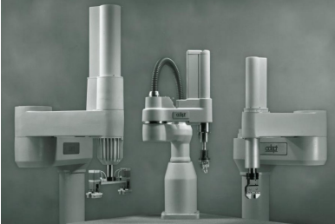

**Fig 7. Examples of AdeptOne SCARA robots**

Robotics in the **1980’s** was a rising star, not only in Japan but in all the developed countries. It appeared as a promising field that drew the interest of journalist, scientists, policy makers and also common people.

Despite the significant progress undergone in the 1980’s, the need for robots that could carry out task at high speed pushed the scientific research to design innovative kinematic structures. The idea of employing parallel kinematic chains instead of the classical serial kinematic chains was put forward and led to a type of lightweight robot featuring the capability of moving at high speed. The archetype of this kind of robots was the Delta robot (that appeared in 1992), conceived by the Swiss scientist Reymond Clavel at the Ecole Poly-technique Fédérale de Lausanne (EPFL). This type of robot, designed by Clavel in his PhD thesis, had three translational DOFs and one rotational DOF (Clavel, 1991). With respect to serial robots, parallel robots featured a smaller work-space, but the capability of operating at much higher speed. The kinematic architecture of the Delta robot was copied in many parallel manipulators, devoted to high speed pick-and-place operations.

The first application of Delta robots was developed by the Swiss company Demaurex in 1992: six Delta robots were operating inside a work cell for loading pretzels into trays. Some years afterwards (1998) ABB developed the Flex-Picker, the world’s fastest picking robot, based on the structure of the Delta robot (Figure 8).

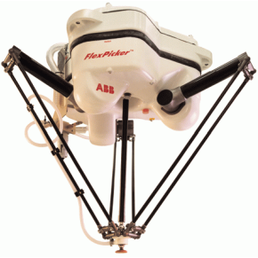

**Fig 8. The ABB Flex-Pitcher robot**

The end of the third generation is conventionally set to the end of the century; beginning from the year **2000**, the industrial robots are considered to belong to the fourth generation (which extends up to the current days). Such robots feature high-level “intelligent” capabilities (such as performing advanced computations, logical reasoning, deep learning, complex strategies, collaborative behavior).

**Evolution and Impact of Automation and Robotics**

In the next decades, research and industry are expected to develop a large variety of autonomous robots for a large variety of tasks and environments. The envisioned robots include, for example, domestic service robots preparing meals, setting the dinner table, and cleaning it up; agriculture robots monitoring fields, analyzing the growth of plants, detecting and classifying plant diseases, cultivating the fields, and collecting the harvest; and robots in retail stores doing the inventory, and replenishing the shelves if needed. One of the biggest challenges is that every combination of task, robot, and environment requires a specific robot control program.

**Approaches In Robotics**

* **Traditional Approach**

Although the fields of computer vision, robotics, and AI all have their fairly separate conferences and specialty journals, an implicit intellectual pact between them has developed over the years. None of these fields is experimental science in the sense that chemistry, for example, can be an experimental science. Rather, there are two ways in which the fields proceed. One is through the development and synthesis of models of aspects of perception, intelligence, or action, and the other is through the construction of demonstration systems (4). It is relatively rare for an explicit experiment to be done. Rather, the demonstration systems are used to illustrate a particular model in operation. There is no control experiment to compare against, and very little quantitative data extraction or analysis. The intellectual pact between computer vision, robotics, and AI concerns the assumptions that can be made in building demonstration systems. It establishes conventions for what the components of an eventual fully situated and embodied system can assume about each other. These conventions match those used in two critical projects from 1969 to 1972 which set the tone for the next 20 years of research in computer vision, robotics, and AI.

At the Stanford Research Institute (now SRI International) a mobile robot named Shakey was developed (5). Shakey inhabited a set of specially prepared rooms. It navigated from room to room, trying to satisfy a goal given to it on a teletype. It would, depending on the goal and circumstances, navigate around obstacles consisting of large painted blocks and wedges, push them out of the way, or push them to some desired location. Shakey had an onboard blackand-white television camera as its primary sensor. An offboard computer analyzed the images and merged descriptions of what was seen into an existing , sting symbolic logic model of the world in the form of first order predicate calculus. A planning program, STRIPS, operated on those symbolic descriptions of the world to generate a sequence of actions for Shakey. These plans were translated through a series of refinement into calls to atomic actions in fairly tight feedback loops with atomic sensing operations using Shakey's other sensors, such as a-bump bar and odometry.

The role of computer-vision was "given a two-dimensional image, infer the objects that produced it, including their shapes, positions, colors, and sizes" (8). This attitude lead to an emphasis on recovery of three-dimensional shape (9), from monocular and stereo images. A number of demonstration recognition and location systems were built, such as those of Brooks (10) and Grimson (11), although they tended not to rely on using three-dimensional shape recovery.

The role of AI was to take descriptions of the world (though usually not as geometric as vision seemed destined to deliver, or as robotics seemed to need) and manipulate them based on a database of knowledge about how the world works in order to solve problems, make plans, and produce explanations. These high-level aspirations have very rarely been embodied by connection to either computer vision systems or robotics devices.

The role of robotics was to deal with the physical interactions with the world. As robotics adopted the idea of having a complete three-dimensional world model, a number of subproblems became standardized. One was to plan a collision-free path through the world model for a manipulator arm, or for a mobile robot—see the article by Yap (12) for a survey of the literature, Another was to understand forward kinematics and dynamics— given a set of joint or wheel torques as functions over time, what path would the robot hand or body follow. A more useful, but harder, problem is inverse kinematics and dynamics-given a desired trajectory as a function of time, for instance one generated by a collision-free path planning algorithm, compute the set of joint or wheel torques that should be applied to follow that path within some prescribed accuracy (13).

It became clear after a while that perfect-models of the world could not be obtained from sensors, or even CAD databases. Some attempted to model the uncertainty explicitly (14, 15) and found strategies that worked, in its presence, while others moved away from position-based techniques to force-based planning, at least in the manipulator world (16). Ambitious-plans were laid for combining many of the pieces of research over the years into a unified planning and execution system for robot manipulators (17), but after years of theoretical progress and long-term impressive engineering, the most advanced systems are stiff far from the ideal (18).

These approaches, along with those in the mobile robot domain (19, 20), shared the sense-model-plan-act framework, where an iteration through the cycle could often take 1-5 minutes or more (18, 19).

* **New Approach**

Driven by a dissatisfaction with the performance of robots in dealing with the real world, and concerned that the complexity of run-time modeling of the world was getting out of hand, a number of people somewhat independently began around 1984 rethinking the general problem of organizing intelligence. It seemed a reasonable requirement that intelligence be reactive to dynamic aspects of the environment, that a mobile robot operate on time scales similar to those of animals and humans, and that intelligence be able to generate robust behavior in the face of uncertain sensors, an unpredictable environment, and a changing world. Some of the key realizations about the organization of intelligence were as follows:

• Agre and Chapman at MIT claimed that most of what people do in their day-to-day lives is not problem-solving or planning, but rather it is routine activity in a relatively benign, but certainly dynamic, world.Furthermore the representations an agent uses of objects in the world need not rely on naming those objects with symbols that the agent possesses, but rather can be defined through interactions of die agent with the world (21, 22).

• Rosenschein and Kaelbling at SRI International (and later at Teleos Research) pointed out that an observer can legitimately talk about an agent's beliefs and goals, even though the agent need not manipulate symbolic data structures at run time. A formal symbolic specification of the agent's design can be compiled away, yielding efficient robot programs (23, 24).

• Brooks at MIT argued that in order to really test ideas of intelligence it is important to build complete agent which operate in dynamic environments using real sensors. Internal world models that are complete representations of the external environment, besides being impossible to obtain, are not at all necessary for agents to act in a competent manner. Many of the actions of an agent are quite separable—coherent intelligence can emerge from independent subcomponents interacting in the world (25-27).

All three groups produced implementations of these ideas, using as their medium of expression a network of simple computational elements, hardwired together, connecting sensors to actuators, with a small amount of state maintained over clock ticks.

Agre and Chapman demonstrated their ideas by building programs for playing video games. The first such program was called Pengi and played a concurrently running video game program, with one protagonist and many opponents which can launch dangerous projectiles (Fig. 1). There are two components to the architecture visual routine processor (VRP), which provides input to the system, and a network of standard logic gates, which can be categorized into three components: aspect detectors, action suggestors, and arbiters. The system plays the game from the same point of view as a human playing a video game, not from the point of view of the protagonist within the game. However, rather than analyze a visual bit map, the Pengi program is presented with an iconic version. The VRP implements a version of Ullman's visual routines theory (28), where markers from a set of six are placed on certain icons and follow them. Operators can place a marker on the nearest opponent, for example, and it will track that opponent even when it is no longer the nearest. The placement of these markers was the only state in the system. Projection operators let the player predict the consequences of actions, for instance, launching a projectile. The results of the VRP are analyzed by the first part of the central network and describe certain aspects of the world. In the mind of the designer, output signals designate such things as "the protagonist is moving," "a projectile from the north is about to hit the protagonist," and so on. The next part of the network takes Boolean combinations of such signals to suggest actions, and the third stage uses a fixed priority scheme (that is, it never learns) to select the next action. The use of these types of deictic representations was a key move away-from the traditional AI approach of dealing only with named individuals in the world (for instance, opponent-27 rather than the deictic the-opponent-which-is-closest-to-the-protagonist, whose objective identity may change over time) and lead to very different requirements on the sort of reasoning that was necessary to perform well in the world.

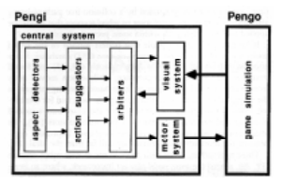

**Fig 9. The Pengi system**

These architectures were radically different from those in use in the robotics community at the time. There was no central model of the world explicitly represented within the systems. There was no implicit separation of data and computation-they were both distributed over the same network of elements. There were no pointers, and no easy way to implement them, as there is in symbolic programs. Any search space had to be a bounded in size a priori, as search nodes could not be dynamically created and destroyed during a search process. There was no central locus of control. In general, the separation into perceptual system, central system, and actuation system was much less distinct than in previous approaches, and indeed in these systems there was an intimate intertwining of aspects of all three of these capabilities. There was no notion of one process calling on another as a subroutine. Rather, the networks were designed so that results of computations would simply be available at the appropriate location when needed.

Most of the behavior-based robotics work has been done with implemented physical robots. Some has been done purely in software (21), not as a simulation of a physical robot, but rather as a computational experiment in an entirely make-believe domain to explore certain critical aspects of the problem. This contrasts with traditional robotics where many demonstrations are performed only on software simulations of robots.

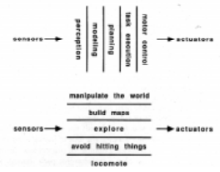

**Fig 10. The traditional decomposition for an intelligent control system within AI**

**Research On Service Robots**

**Definitions**

Defining service robots requires to clarify both the precise meaning of “robot” – which has a formal standard, although it is sometimes applied loosely – and that of “service”. The latter can refer either to the sector of the economy (as opposed to manufacturing, or the primary sector), or the type of tasks that robots perform – service as in “serving and assisting human workers”, in any sector of the economy.

The official definition of robot, widely cited in the scientific and technical literature, is laid out in the ISO 8373:2012 standard (International Organization for Standardization [ISO], 2012)):

Robot. Actuated mechanism programmable in two or more axes with a degree of autonomy (i.e., the ability to perform intended tasks based on current state and sensing, without human intervention), moving within its environment, to perform intended tasks.

The ISO standard distinguishes between industrial robots and service robots, based on the sector of economic activity in which they are used.

* **Industrial Robot**

automatically controlled, reprogrammable [i.e., designed so that the

programmed motions or auxiliary functions can be changed without physical alteration], multipurpose [i.e., capable of being adapted to a different application with physical alteration] manipulator [i.e., machine in which the mechanism usually consists of a series of segments, jointed or sliding relative to one another, for the purpose of grasping and/or moving objects (pieces or tools) usually in several degrees of freedom], programmable in three or more axes, which can be either fixed in place or mobile for use in industrial automation applications.

* **Service robot**

robot that performs useful tasks for humans or equipment excluding industrial automation applications. Industrial automation applications include, but are not limited to, manufacturing, inspection, packaging, and assembly. While articulated robots used in production lines are industrial robots, similar articulated robots used for serving food are service robots.

The ISO standard also distinguishes between professional service robots, used for commercial task, usually operated by a properly trained operator, and personal service robots, operated by consumers in non-commercial settings. Examples of the former are cleaning robots for public places, delivery robots in offices or hospitals, rehabilitation and surgery robots in hospitals, all of which are clearly used in productive settings in services. Personal service robots, by contrast, range from health applications (automated wheelchair, personal mobility assist robot) to personal entertainment (domestic servant robot, and pet exercising robot), but are products used by consumers in a private setting.

Although the term robot is sometimes used to denote interchangeably either physical machines or software (including in the scientific literature), whenever we make the distinction between industrial and service robots, we always mean physical machines. The engineering literature describes service robots as the technological evolution of industrial robots, insofar as their area of application is technically more complex. Indeed, consistently with Fernández-Macías et al (2020), we can describe the technical progress of robotics as a continuous series of incremental improvement, starting from long-established mechatronic automation technologies, towards autonomous robots who operate in standardised industrial environment, and finally expanding to interact with humans, operate in unstructured environments, and perform complex tasks, with a higher degree of autonomy. All these requirements involve additional technical obstacles, which have made the development of service robots more challenging.

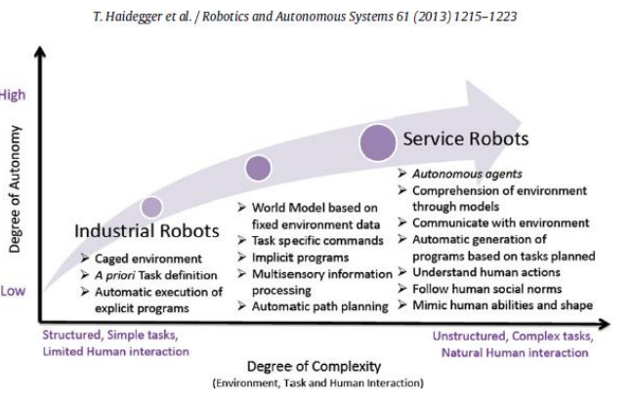

**Fig 11. The evolution of industrial and service robots**

As Haidegger et al. (2013) note, there is a need to standardise the nomenclature of service robots based on the technical tasks that they can perform, and the level of their interactions that they allow with humans (see Figure 1). They outline a potential methodology for doing so, in engineering terms. In the social science literature, the relevant difference between service and industrial robots is the human quality of the tasks that they perform. For instance, Decker et al. (2013) show that whereas industrial robots mostly perform routine manual tasks in a standardised setting, service robots are expected to perform less routine (or less standardised) tasks, and those that require higher cognitive function for humans.

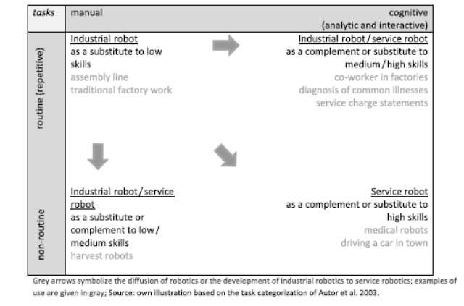

**Fig 12. Task complexity of industrial and service robots**

The framework proposed by the authors implies that, whereas industrial robots affected low-skilled factory work in assembly lines, service robots may affect employment in high-skilled service sector occupations. Regardless of their potential of automation, we should note non-routine cognitive or social interaction tasks are not necessarily linked to high-skilled occupations: many of them are in mid and low-skilled service sector and administrative jobs, such as waiters, personal service workers, retail workers, clerks and secretaries. Crucially, the authors stress that it is difficult to make predictions with any certainty and that whether service robots may complement or substitute human workers depends on the precise tasks that they perform.

**Data on service robots**

The most detailed and substantial evidence on the diffusion of robots in European companies is the Eurostat Community Survey on ICT usage in enterprises, which contributes to the European Commission Digital Economy and Society Index.10 The 2018 edition of the survey included an optional module on the use of robots, as well as 3D printers.11 In this section, we will consider the question related to robots only, leaving aside the separate questions on 3D printers. The same survey is being repeated in the 2020 survey, though it was not included in the 2019 edition. As a result, only the 2018 data is currently available. The data does not cover some countries that did not reply to the optional module, namely Belgium, Ireland, Croatia, Latvia, Luxembourg, and the United Kingdom. For the 2020 edition, all questions on robotics are compulsory.

The optional module F of the 2018 ICT Community Survey questionnaire asks if the enterprise uses any of the following types of robots, and gives a few examples of their applications:

a) Industrial robots (e.g. robotic welding, laser cutting, spray painting, etc.)

b) Service robots (e.g. used for surveillance, cleaning, transportation, etc.)

The definition of service robot follows closely our reference definition:

A service robot is a machine that has a degree of autonomy and is able to operate in complex and dynamic environment that may require interaction with persons, objects or other devices, excluding its use in industrial automation applications.

Like our reference definition, this one permits, but does not require, interaction with humans. However, it is unclear what the “degree of autonomy” contrasts with the level of autonomy often found in industrial robots. Consistently with our interpretation, the questionnaire goes on to say that “software robots (computer programs) and 3D printers are out of the scope of the following questions.” (Emphasis in the original).

Both in the 2018 and 2020 survey case the respondents reply that they use service robots, the survey goes on to ask their areas of application among those listed, with multiple selections possible:

a) Surveillance, security or inspection tasks (e.g. use of airborne drones, etc.)

b) Transportation of people or goods (e.g. use of automated guided vehicle, etc.)

c) Cleaning or waste disposal tasks

d) Warehouse management systems (e.g. palletising, handling goods, etc.)

e) Assembly works performed by service robots f) Robotic store clerk tasks g) Construction works or damage repair tasks

We should note that, despite the definition used in 2018 excluding industrial automation applications, its results show numerous cases of service robots used in the manufacturing sector. (Indeed, assembly is a typical manufacturing task.) In what follows, whenever possible we will report the figures distinguishing between service sectors and manufacturing.

**Data on diffusion**

The results of the Eurostat ICT Community Survey in 2018 are the best available evidence on the prevalence of robots in the European Union today. Across all participating countries, only around 2% of companies reported using service robots in 2018. By comparison, industrial robots are found in 5% of firms. Considering that the figure for service robots also includes companies in manufacturing by Eurostat’s definition, the prevalence of robots that are actually used in the service sector is even lower, as described in the following subsection.

The adoption of service robots varies across Member States. Although the figures reported by Eurostat are rounded to the nearest percentage point, we can still meaningfully distinguish between countries. The prevalence of service robots is highest among Spanish and Italian companies, at 4% of firms in both countries. A second group of adopters, with a prevalence of 3% includes Danish, French, Portuguese, and Finnish firms. Perhaps surprisingly, only around 2% of firms in Germany report using service robots. This cross-country pattern defies any easy generalisation, except perhaps noticing a higher-than-expected share in countries with higher unemployment rates, such as Italy and Spain.

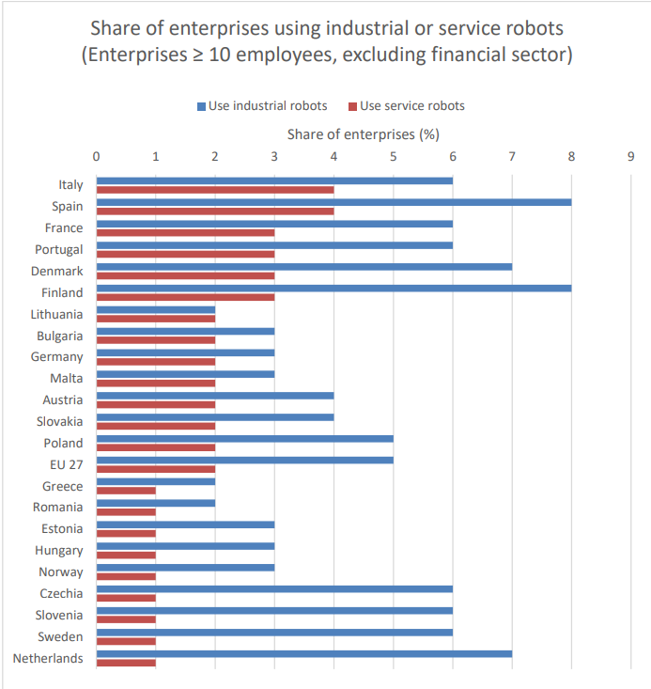

**Fig 13. Only a minority of EU companies use robots. Industrial robots are more common than service robots**

Larger companies are more likely to use service robots in every country. This is no surprise, considering that medium and large enterprises are likelier to adopt new technology in general. They also have easier access to capital to make the necessary investment, and can tap the necessary skills. Figure 2 shows the breakdown in the share of companies using service robots by number of employees. As before, the numbers presented by Eurostat include both manufacturing and services (excluding finance), and are rounded to the nearest percentage point. Service robots are most common in large Italian and Danish companies (around 16%), and are found in 13% of Finnish enterprises and 12% of Danish and French ones. Interestingly, among the small and mid-sized German companies that make up the Mittelstand in Germany, only 3-4% of them use service robots, compared to 10% in large companies in the same country. This low level of adoption also contrasts to 3–7% in similarly-sized Spanish, Italian, and Portuguese firms.

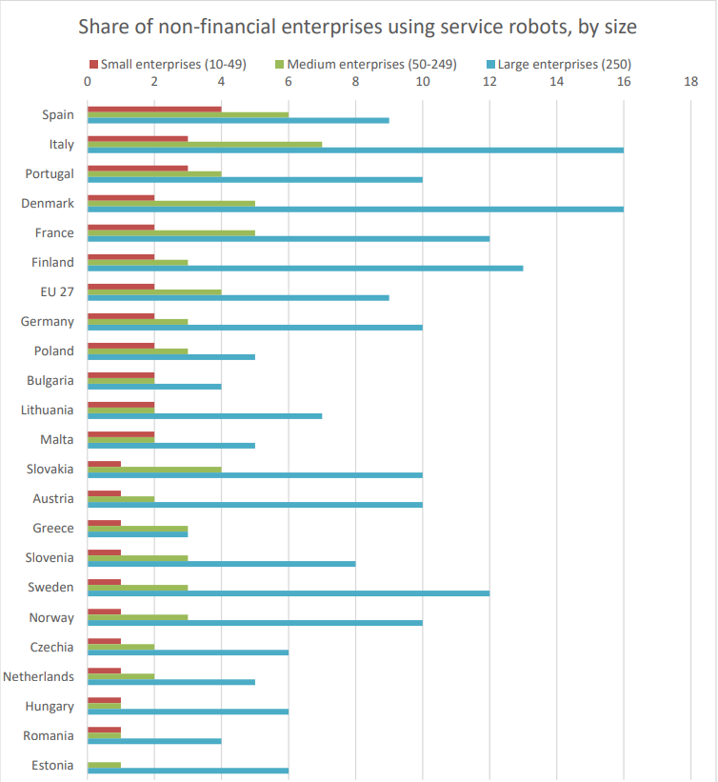

**Fig 14. Larger companies are much more likely to use service robots than smaller companies**

These differences across Member States underscore the need to understand the factors influencing the adoption of service robots, including the sectors and applications in which they are used.

**Data on applications**

The use of service robots is more widespread in retail trade, but also with some isolated clusters in ICT, telecommunications and business support. Eurostat presents the number of companies with 10 or more employees using service robots disaggregated by sector, spanning manufacturing and services. We present the tables separately for the manufacture of goods (Table Table 2) and for services, including construction, and excluding finance (Table Table 1). In services, the highest European average rate of adoption is in retail excluding motor vehicles at 4%, led by Danish and Finnish retail companies, 12% and 10% of which, respectively, use service robots. A similar pattern, albeit at a lower scale, is found in wholesale trade. In services, there are a few isolated clusters of sectors in countries with unusually high rates of adoption of service robots, including 21% of Norwegian and 10% of Portuguese companies working in repair of computers and communication equipment, 8% of Norwegian and Estonian telecommunications companies, and 8% of Portuguese companies in the electricity, gas, steam air-conditioning and water supply industry. We cannot rule out the possibility that these differences across countries are also driven by different interpretations or confusion by respondents over the distinction between industrial and service robots. We should note that the 2020 version of the questionnaire formulates the definitions more extensively and gives more examples, which should help in reducing confusion.

Compared to service sectors, relatively more companies in manufacturing report using service robots, as Table Table 2 shows. On average across the EU, the share of companies using service robots is highest in the automotive manufacturing sector at 7%, going as high as 15% in Slovakia, 13% in Italy, and 12% in Portugal. The service robots in question are presumably a more advanced iteration of industrial robots already used in car manufacturing, as described above in Heidegger et al. (2013) and Fernández-Macías et al (2020). Beyond the automotive sector, a relatively high share of companies report using service robots in the manufacture of petro-chemicals, pharmaceuticals, rubber and plastic: 10% of Danish and Italian companies, 8% of French ones. Service robots tend to be relatively common across Europe also in the manufacture of electrical equipment and machinery, and in high-tech manufacturing of computers and electronics in Italy and Estonia.

We do not know exactly what kind of robots the companies actually installed from these figures alone. However, we know why they are being used, by looking at some of the more common applications cited by the companies that adopted them. Table Table 3 shows the most common applications of service robots by companies that operate strictly in service sectors, while Table Table 4 lists the applications for service robots by companies that have adopted them in the manufacturing sectors. The most common use-case in any sector is warehouse management, cited by 44% of companies using service robots. (This percentage is a subset of the small share of companies that report using service robots in the survey.) This application is common for the broad retail and logistics sector, namely for over 60% of companies using service robots in retail and wholesale trade and 38% of those using them in transportation. Warehouse management is also cited by 50% of the companies that use service robots in manufacturing, especially in food, food preparation and beverage sectors, wood and derived products, an in the petrochemical sector. Here, too, we can easily see how robots can be tasked with moving stock of products in warehouses. In other sectors, such as professional, scientific and technical activities, however, it is harder to imagine how those companies are service robots for warehousing tasks. The second most common application of service robots is transportation of people or goods, cited by 20% of companies that report using service robots in all sectors, including retail and logistics in services, and across manufacturing. This task overlaps somewhat with warehouse management, and can be carried out by a variety of autonomous and semi-autonomous vehicles, or conveyor systems.

The third most common application for service robots is for assembly tasks, mostly in manufacturing, particularly of high-tech computers and electronics (76% of companies using service robots) and motor vehicles (59%). This has been a traditional task for industrial assembly robots from the beginning, because it is standardised and involves precise repetitive movements.

The distinction between industrial and service robots in assembly is not clear, though it presumably involves the degree of autonomy, complexity, and human interaction required of the robot.

An equally common use for service robots, this time more prominent in the service sector, is cleaning and waste disposal, notably in energy supply, but also in accommodation and food and beverage (50% of companies that use service robots), and in administrative and support services (46%). Here, we should perhaps distinguish between on the one hand robots designed for specialised cleaning tasks, such as pipes, tank, machinery, as well as waste disposal machines, and on the other hand more generic robots used for cleaning surfaces. We expect the former to be more common in energy and manufacturing sectors, and the latter to be used on large surfaces such as factory floors, warehouses, hotels, and exhibition spaces.

Among less-frequent uses of service robots are surveillance and inspection, cited by 15% of companies using service robots and construction or damage repair tasks, cited by 8%. Service robots for surveillance and inspection tasks is especially used in professional services, information and communication, and across manufacturing. These come in many shape or forms, depending on the structure or machinery to inspect, or space to monitor. Robotic store clerk tasks are relatively rare, used in only 9% of companies, but somewhat more common in retail trade and trade of motor vehicles. Here, too, we cannot say precisely what type of machinery is meant in this case. Perhaps they may be simply self-service kiosks, though that would stretch the definition of robot used by Eurostat. Robots that are used in construction or damage repair tasks are more common in the construction sector, the trade of motor vehicles, and manufacturing.

Finally, we should note that about 12% of those using service robots declare doing so for other reasons than the ones listed above. The share is higher in services, especially administrative and support services (35%), trade in automotive (29%), accommodation, food, and beverage services (28%); and information and communication services (24%). These sectors, and the types of robots they use, may also prove interesting. Overall, the data seem to suggest that among the few companies that use service robots, they use them for dirty, strenuous, or repetitive tasks, in line with our expectations.

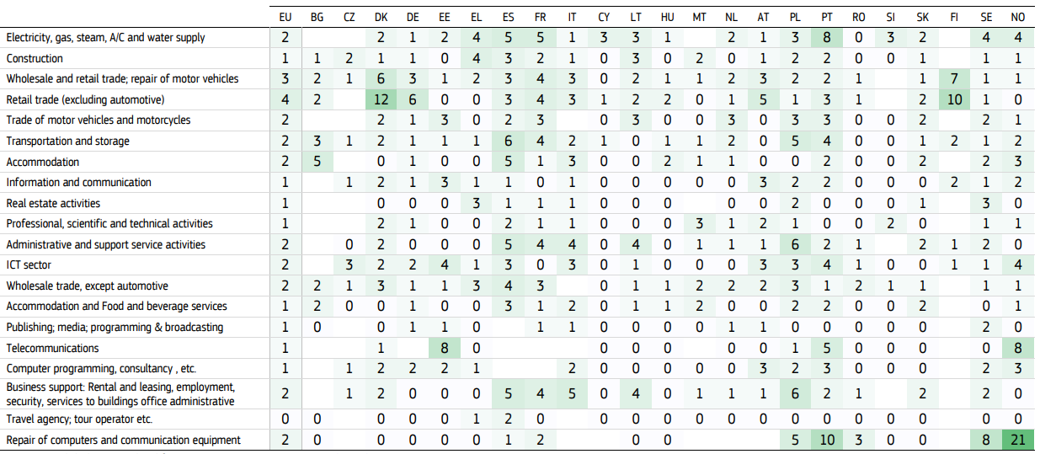

**Table 1. Percentage of enterprises of 10 or more employees using service robot, non-manufacturing sectors**

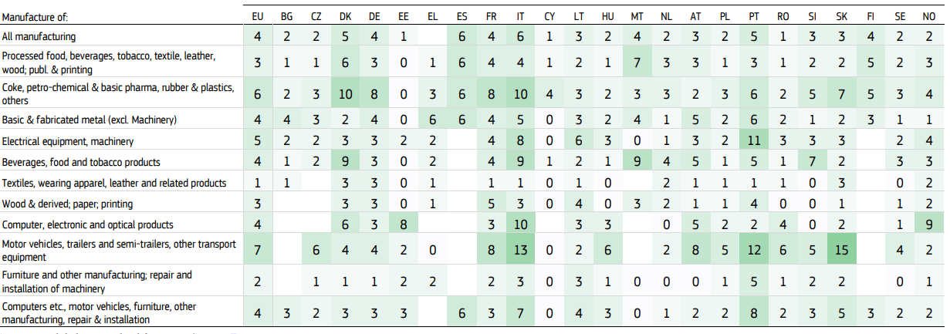

**Table 2. Percentage of enterprises of ≥ 10 employees using service robots, manufacturing sectors**

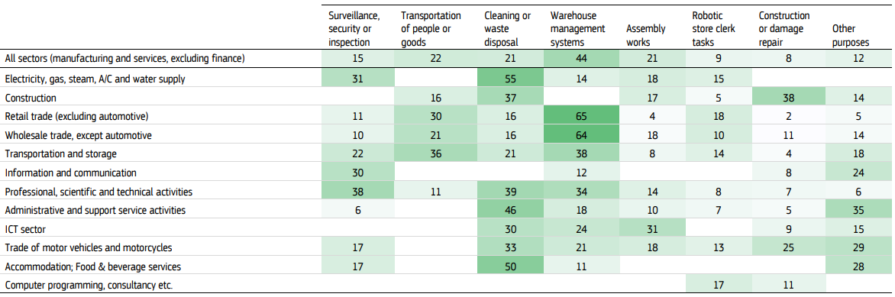

**Table 3. Applications of service robots in enterprises of the service sector that use them (EU average for enterprises of ≥ 10 employees using service robots, service sectors)**

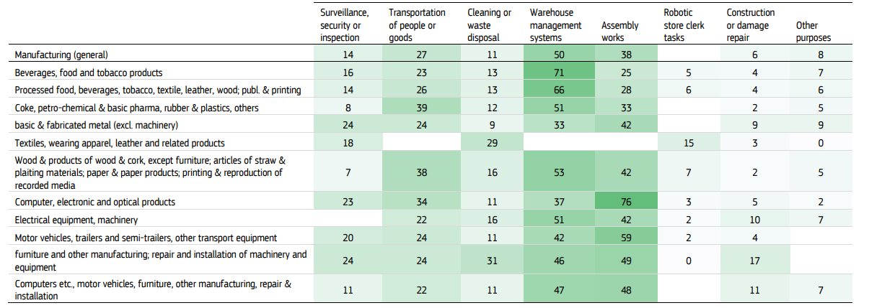

**Table 4. Applications of service robots in enterprises of the manufacturing sector that use them (EU average for enterprises of ≥ 10 employees using service robots, manufacturing sectors)**

**Remarks on applications, limitations, and extensions of existing data**

The figures reported by Eurostat give a valuable general overview – the only one of its kind – on the adoption, distribution and applications of service robots across European companies. In general, the ICT community survey is designed primarily to appraise the state of technology adoption across Member States. It is not intended to provide detailed evidence at the level of individual companies on the reasons for adopting technologies, or the ways in which they are embedded in the firm. As a result, the survey is relatively imprecise.

The survey uses an expansive interpretation of service robot that partially overlaps with its own definition of industrial robot. This may have caused confusion among respondents, and makes it harder to focus precisely on the service sector, as distinct from manufacturing. The survey asks whether companies use any industrial robot, or any service robot, but not their type or quantity. Service robots are not commoditised – they come in different types and sizes, and imply vastly different levels of investment and integration into company processes.

The survey results only report the share of companies using robots disaggregated by country, size, and sector. In any of these, percentages are rounded to the nearest integer, which makes it difficult to compare precisely the share of adopters across different countries. Furthermore, the sector disaggregation, at approximately NACE 1-digit, is quite broad. Finally, the list of applications for service robots that companies could choose from is somewhat limited. In most cases, we can only surmise the specific type of service robot they refer to, and their application. Among the companies that use service robots, 12% use them for different purposes than those listed, which indicates that the use-cases envisaged by the survey where too limited. Since the only available figures refer to 2018, we cannot know how the adoption of service robots has changed in the last couple of years. Moreover, the 2018 module on service robots and 3-D printers of the ICT survey was optional, which means that not all Member States collected these statistics. Once the results of the 2020 ICT survOverall, the data of the ICT Community Survey of Enterprises answer the question of how many service robots there are, by looking at their prevalence across companies (and, soon, their growth), though it does not inform us on the stock of installed units, or their value.

The data can also point us to what they do, by looking at the sectors in which they are installed, and the applications for which they are used. However, the survey is silent on the deeper reasons of innovation and the intra-firm dynamics with respect to labour policies.ey are released, we will be able to draw on a larger number of countries, and compare how countries and sectors have evolved.

By contrast, the World Robotics – Services report by the IFR describes in detail the variety and capabilities of existing service robots, and lists extensively their areas of application. However, the globally aggregate sales figures it collects can only give us an approximate idea of the prevalence of service robots. The sales projection included in the report should also be interpreted with caution, as they come from producers themselves, who have an interest in generating interest in their products. Moreover, the sales projections were compiled before the COVID-19 pandemic, which may affect the industry in unpredictable ways. On the one hand, the pandemic may increase the desire to automate tasks and expand e-commerce, boosting the sales of robots. On the other hand, it may also disrupt sectors like aviation or shipping, thus reducing the demand for some types of robots.

Ideally, to fully understand how service robots are being used in the service sector, we would like to combine the breadth and coverage of the ICT community survey with the depth of classification of the IFR. To our knowledge, the scope of existing Eurostat surveys, including the ICT community survey, is currently too broad to address these points conclusively. Understanding fully the patterns of adoption of service robots would probably require an ad-hoc survey targeting enterprises in the service sector, focused on the specific kind of service robot technology used, it applications and tasks, and how it fits with existing workforce and operations. We can also obtain this sort of insight on a smaller scale, through case studies. We can select specific examples of service robots, using the IFR-UNECE classification as a reference, and the names of the robots and companies listed there as a starting point. The following section describes a tentative taxonomy of service automation that could help guide the selection, and distinguish the different types of automation in the service sector.

**Analysis**

**Challenges in Industrial Robotics**

This analysis moves beyond cataloging obstacles to interrogate their root causes and interconnections, offering an evidence-based framework for understanding adoption complexities. Economically, high initial costs—spanning acquisition, installation, and programming—deter SMEs, with RoI varying widely (3–5 years in automotive due to high utilization, 5–7 years in healthcare due to precision and regulatory demands, and 4–6 years in agriculture due to seasonality). Automotive robotics cut costs by 30% , yet healthcare’s 40% precision gains come with extended RoI, and agriculture’s implementation of optimized trajectory planning for parallel robots in tomato packaging achieves a 31% efficiency boost, but the overall impact is influenced by seasonal constraints. Modular designs offer relief, reducing the total cost of ownership (TCO) by 20% and boosting SME efficiency by 30% through reconfigurable components, yet their scalability across diverse tasks remains understudied, a gap this review highlights.

Technically, integrating advanced robots with legacy systems poses significant hurdles due to incompatible infrastructures and outdated controls. Calibration errors, such as those in pose serving with maximum allowable thresholds, further complicate precision in legacy retrofits. Plug-and-play solutions and digital twin architectures using Open Platform Communications Unified Architecture (OPC UA) streamline this process, enhancing adaptability and real-time efficiency. However, retrofitting costs and industry-specific needs complicate universal adoption, particularly in SMEs lacking resources for extensive upgrades. This tension between innovation and compatibility underscores a broader challenge: while robotics evolves rapidly, industrial ecosystems lag, creating a mismatch the literature rarely critiques holistically.

Interoperability compounds these issues, as the absence of standardized communication protocols hampers multi-vendor robot coordination. OPC UA enjoys high adoption in Europe and the US, while Robot Operating System (ROS) 2 sees moderate uptake, improving autonomy and collaboration. ISO 10218 safety standards are globally embraced, yet the lack of a unified framework—like a fully interoperable ROS or OPC UA variant—limits seamless integration, a persistent barrier evident in smart manufacturing inefficiencies. This standardization gap not only stifles technical synergy but also delays scalable deployment, an area where research offers solutions but lacks consensus.

Ethically, robotics’ rise sparks workforce displacement fears, with manufacturing risking 35% of jobs, logistics 30%, and healthcare 20%, offset by new roles (25%, 22%, and 18%, respectively) in programming and maintenance. Collaborative robotics fosters upskilling and boosting retention, yet the literature overlooks long-term societal impacts, e.g., regional disparities in job creation. Cybersecurity emerges as a parallel concern in interconnected systems, with threats like unauthorized access and data breaches mitigated by blockchain (reducing risks significantly) and AI-driven anomaly detection. However, these countermeasures demand computational resources, raising cost and scalability issues anew. Philosophical debates further complicate this landscape, questioning how automation balances efficiency with human autonomy, a discussion often sidelined in technical analyses.

These challenges—economic, technical, interoperability, and ethical—are not discrete but interwoven, as visualized in projected robot installations, which stabilize post-2024 due to unresolved barriers. High costs limit SME access, integration stymies legacy adoption, standardization delays multi-robot systems, and ethical concerns slow societal acceptance. Mitigation strategies, like modular designs, OPC UA, and blockchain, address symptoms, yet their systemic integration remains nascent. This synthesis reveals a critical oversight; while robotics excels technologically and in applications, adoption falters without cohesive solutions.  Will explore these interdependencies further, proposing research to bridge these gaps and ensure robotics’ sustainable evolution.

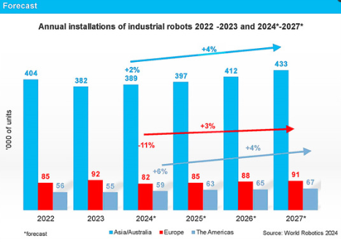

**Fig 15. Forecast of global industrial robot installations (2024–2027). Projected growth stabilizes, reflecting persistent adoption challenges**

**Challenges of the construction robotics**

There are many challenges of implementation of construction robots. The challenges of implementation of construction robotics technologies had been divided into different categories as:

* **Cost:**

High cost acquiring and maintaining the technologies is one of the challenges to implementation of construction robotics. The high cost of the technologies implementation construction robotics where the automation technologies are so expensive. The purchase and implementation of the technologies are costly that the firm which has a good turnover and market competition can only afford these technologies, In addition, the automation technologies need to updated and maintained and most of them are expensive to update and maintain. Maintenance cost for the new robotics equipment normally is higher because of the need for the special technician to do the maintenance job.

* **Incompatibility of the technologies:**

Incompatibility of the technologies with existing practices and current construction operations. Workers prefer the former and proven solution instead of innovative methods and technologies due to the volatile and unpredictable nature of the construction environment.

* **Nature of construction industry:**

The problem of fragmentation is the project process whether conventional or modern methods of construction are used. Fragmented nature of the construction industry inhibits the implementation of new technologies. Development of construction robots are technologically difficult because of the nature of the construction work processes itself and to work in construction where the robots need to be robust, flexible, with high mobility and versatility.

* **Technological usability:**

Technologies are difficult to use and not easily understood due to the difficulties of the software. The high sophistication of the robot control system becomes a more challenges parts to workers in the construction industry who are more low education workers. Robotics technologies are sophistication to control especially of the programming procedure and very difficult introduction in the construction industry.

* **Technologies adoption by workers:**

Technologies are not easily accepted by workers in the working places. In some countries, active workers unions look upon these technologies as a way to replace the workers. This can show that the implementation of robotics in the building must fully support not only of labour but also of management at all levels in order to bring the expected results. For example, In Australia, any attempt to introduce robots on to a construction site must be based on three-way negotiation between the men, management and the union where building union representative must be convinced the use of robots in construction will not threaten their jobs.

* **Retraining of workers:**

Most of the workers in the construction industry are foreign which consists of 93% are low-skilled labour. So that, re-training of construction workers becomes a compulsory to upgraded skills for a semiskilled worker or through seminars and workshops to increased understanding of the technologies in the industry and on the worksites. Training problem provides to the employees to interact with the new robotic equipment which will take time and cost a lot of money in the financial output. Special training for the workers to operate the robots and the contractor must invest heavily in training and educate the workers.

* **Resources:**

The difficulties of implementation of construction robotics due to the high cost and only companies which have a good turnover and market competition can afford these technologies. Limited resources available to the medium and small-sized firms to adopt these technologies because every construction process is unique in character and same technologies are not appropriate for all condition. Large companies have enough investments to inculcate new technologies as compared to small and medium firms.

**Case study of Malaysia**

**Challenges of the implementation of construction robotics technologies in Malaysia**

Ten statements relating the challenges of implementation of construction robotics technologies was listed and presented in Table. Table showed the majority of the respondents strongly agreed that maintenance costing to be the main challenges of the implementation of construction robotics technologies in Malaysia. Followed by the cost to update the technologies was ranked second and the third was a high cost to acquire the construction robotics technologies. The results were different from previous research which stated that the cost to acquire the technologies as the top challenges. However, 9 years had passed since the research had been conducted as recent research by mentioned that the automation technologies were expensive to update and maintain. The maintenance cost for the new robotics technology is more costly because of the need for the special technician for the maintenance job. Only the companies who have a good turnover and market competition can afford these technologies due to the high cost of owning and operating automated technologies.

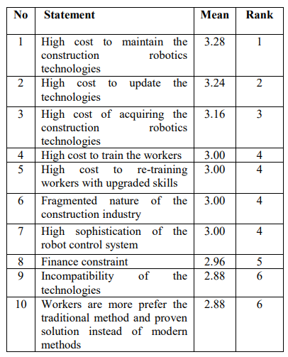

**Table 5. Ranking of the Challenges of the implementation of construction robotics technologies in Malaysia**

Based on the results, respondents agreed that the cost to train the workers, re-training workers to upgrade skills, fragmented nature of the construction industry and high sophistication of the robot control system was ranked fourth. The need for a trainer to train the workers on how to handle the sophistication of the robot control system becomes a challenge for industry players. This is because 93% of workers in Malaysian construction industry are low-skilled labours.

In order to make the workers understand the operation the robotic technologies, training, and retraining of workers become compulsory to upgrade skills for semi-skilled workers in order to increase their knowledge for the robotics. This will cause increase in time and cost. It is difficult to introduce high sophistication robot control system in construction site as workers were generally lower educated. The fragmented nature does inhibit the implementation of new technologies but will bring a negative influence on the project performance which will be the challenges for the companies to adopt of the technologies.

Financial constraint was ranked fifth, Incompatibility with current practices and construction operations and workers prefer the traditional method and proven solution instead of the modern method were ranked sixth. A minority of respondents agreed, hence the low mean value. Due to the limited resources available to the medium and small sized firm were difficult to adopt these technologies because every construction process is unique in character and same technologies cannot be used all the time. Most of technologies were not easily accepted by workers in the working places. For example, the adoption of Industrialised Building System (IBS) was low due to the lack of skills and knowledge of the discipline among the workers who are more dependent to the conventional construction methods.

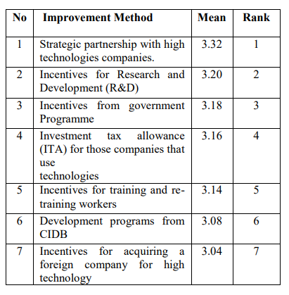

**Table 6. Improvement methods**

**SWOT Analysis of Robotics**

**Method**

A SWOT analysis was undertaken to understand the strengths, weaknesses, opportunities and threats of robotic technology in palliative, supportive and end-of-life care. A SWOT approach was chosen for its ability to provide a wide narrative overview of the subject. A systematic review was not considered for the following reasons. First, there are relatively few published papers specifically about the use of robots in palliative and end-of-life care. Second, there is great heterogeneity in the published work about healthcare robotics, involving different study designs and outcome measures (e.g. social vs assistive robotics). Therefore, most meaningful analyses will likely be derived from narrow systematic reviews, which focus on specific applications of robotics in palliative care. We therefore chose the SWOT approach to provide an overview of robotics in this area. This will support the conduct of focused systematic reviews to further explore the areas identified by this SWOT analysis.

**SWOT development**

Potential applications of robots in palliative care were imagined through discussion and debate, through meetings between computer scientists (T.R.P. and B.S.), a palliative care researcher (S.M.) and a clinician in palliative care (A.C.N.). A protocol was developed to explore the capabilities of a robot to exhibit human emotional responses (see supplementary files). The robot was developed (by B.S. and T.R.P.) and was presented (by A.C.N.) at a series of events which aimed to imagine the future of healthcare. The opportunities and risks of using robots to support palliative care patients and their families, and the delivery of services were discussed. These events were

1. A public engagement debate with a multi-professional audience including computer scientists, academics, clinicians, social scientists, ethicists and members of the public (University of Liverpool). Data were generated via a group discussion where feedback was recorded via flip chart paper.

2. A computer science seminar attended by computer scientists, data experts and healthcare professionals (University of Liverpool). Data were generated via a group discussion where feedback was recorded via flip chart paper.

3. An oral presentation at a dedicated robotics session at an international palliative care conference (the Association for Palliative Medicine (APM) Annual Supportive & Palliative Care (ASP) conference, Belfast, 201721). Following the session, written feedback was recorded to summarise the questions, discussion and debate.

Data from these events were collated and categorised into the themes of strengths, weaknesses, opportunities and threats. The SWOT was further informed by a round table discussion at the Winter Forum of the Palliative Care Institute Liverpool, University of Liverpool. This is a multi-professional meeting involving researchers, healthcare professionals and public representatives. Forum attendees (approximately 50) were invited to participate in the round table discussion. A modified world café method22 was used to answer the question ‘what are the strengths, weaknesses, opportunities and threats of robotic technology in palliative care?’ The procedure involved three 20-min rounds of conversation for rotating small groups seated around a table. A facilitator (A.C.N.) promoted discussion through open questions and a scribe (T.McG.) collected written notes. The brief was to discuss their opinions of the (1) strengths, (2) weaknesses, (3) opportunities and (4) threats of robotic technology in palliative care. In total, 15 individuals (5 lay representatives, 5 clinicians, 3 researchers and 2 nurses) voluntarily participated in the round table discussion. After completion of the group discussion, individuals were invited to share their insights with the rest of the forum attendees.

**Strengths of robotic technology**

Robots can work automatically without human interference, meaning they can undertake time-saving tasks. They are useful in environments that are hazardous for humans (e.g. ionising radiation or airborne diseases).Furthermore, a robot can be standardised to ensure consistent, error-free performance, which is not affected by anxiety, fatigue and hunger.1 Some individuals may prefer robot interactions for certain procedures, for example, for convenience (e.g. blood pressure monitoring) or to maintain privacy or avoid embarrassment (e.g. personal care). A robot does not require lengthy training or educational interventions which are necessary for human workers. For example, robots have the potential to rapidly incorporate software updates to improve performance based on best evidence, whereas for human workforces, adoption of new systems or changing practice is comparatively more challenging. Furthermore, continued technological developments will create further opportunities to integrate robotics in healthcare, for example, improvements in battery storage capacity, graphene, quantum computing, fifth-generation (5G) Internet, artificial intelligence (AI)29 and Internet of things (IoT) technology.

**Weaknesses**

Robots are expensive and require supporting infrastructure to function (e.g. Internet connection, power supply and maintenance). Consequently, the technology is currently best suited to affluent healthcare organisations. Issues regarding infection control currently limit the practicality of using robots in some healthcare environments. Robots can only do tasks they are programmed to do; therefore, they are suited for specific tasks but are less useful for problem solving.Robots generally struggle with fine motor activities which reduces their usefulness for dextrous tasks like dressing, cooking and opening doors.Robots can perform repetitive tasks for long periods of time but do not get better with experience (unless this is part of their programming). Robots are unable to feel and express genuine emotion which may reduce emotional connection and contribute to fear and distrust. The expectations and acceptance of robots are likely to differ between patients, caregivers, designers and policy makers. It is therefore important to determine whether individuals want (and will accept) this technology in their lives.

**Opportunities in palliative care**

A general opportunity presented by robotics is to increase the choice and access of healthcare for patients. Furthermore, current evidence suggests robotics can support a number of communication and assistive uses for the elderly. Such uses include applications for supporting mobility, activities of daily living, physical activity tracking/monitoring, medication management, and to support (and monitor) nutrition and hydration. For healthcare professionals, robots may improve the efficiency (and safety) of manual handling44 and cleaning procedures .Robots can potentially support pharmacy processes by improving efficiency of medication dispensing Therapeutic uses for robots include the potential to improve mobility following spinal procedures and to improve limb rehabilitation following stroke. Minimally invasive robotic surgical procedures combined with nanorobotics (robots at the scale of a nanometre (10−9 m)) offers the potential to improve care for patients through nano-procedures (medical and surgical) which do not currently exist. Robots can potentially provide companionship in advanced illness. For example, elderly patients with dementia have been shown to gain therapeutic benefit from using a robotic seal (Paro) as a social companion .Paro may also help older adults without cognitive limitations; however, those with severe mental impairment are unlikely to benefit.

Robots also have the potential to support educational initiatives. For example, in Japan, robots have been used to support health education programmes. Previous studies have demonstrated that social robotics can benefit language and social development in autistic children, presenting an opportunity for robots to facilitate education in wider society to promote better understanding of palliative care. Robots also have the potential to support palliative care training for healthcare professionals by creating immersive learning environments through the use of virtual reality. In addition, robots may enhance highfidelity patient simulation (HPS) by improving the functional ability of the manikin to exhibit emotion, move and respond to the learner.

**Threats**

Robots may widen inequalities in society, as certain individuals and organisations may have no access to this technology. Furthermore, there is a risk that robots may propagate unconscious bias. Evidence demonstrates that the individuals involved in the development and testing of data-driven technologies are generally small and homogeneous; therefore, there is a risk that the technology may not represent the needs of wider society.

Consequently, robotic systems may have implicit perceived social norms which may result in unintended consequences. It is feared that robots will replace human contact and will cause job losses, leading to decreased patient-contact with healthcare professionals, and increased social isolation of the elderly. Such fears have resulted in violence against robots. For public health, there is concern that technological investment will replace other societal initiatives. A number of ethical issues also need to be considered. These include concerns about the robustness and efficacy of robots to ensure human safety. It is important to determine responsibility for robots and their software, (particularly if the devices fail) to prevent breeches of data protection and confidentiality.

Furthermore, this raises questions of whether robots should always follow the instruction of their masters, even if the intended actions are unlawful or harmful (e.g. facilitating use of illicit substances, euthanasia, alcohol consumption, etc.). A robot that chooses (or is programmed) to disobey its master for a particular reason (e.g. to avoid harm) may lose the trust of the operator. These issues emphasise the moral agency of robots, particularly their use with vulnerable individuals with serious illness. In addition, the use (or continued use) of robots in those who lose capacity needs further evaluation (to determine best interests) and debate around other important questions such as whether using robots as social companions (e.g. animal substitutes in dementia) is deceptive. There is also an increased threat to data privacy and protection as robots are likely to access, record and generate a large amount of personal data which could be used without the consent of the individual.

**Limitations**

There are a number of limitations of this analysis. First, a SWOT analysis is limited by a degree of subjectivity and a lack of ability to clearly forecast the future. This SWOT analysis does not include non-English articles. Because China drives much of the innovation in healthcare robotics, it is likely that relevant data were excluded from this article. This analysis is not a systematic review; therefore, it is possible that important data were not included. We are unable to provide conclusions about the usefulness, efficacy or effectiveness of a robot in palliative, supportive and end-of-life care.

**How this work relates to current developments**

There is a lack of studies which specifically examine the potential of robotics in palliative care; however, our discussion supports work from other disciplines that outline the potential of robotics in healthcare.

It is important to note the political importance of healthcare robotics. For example, China is ageing more rapidly than almost any country in recent history. Currently, investment in healthcare robots is a priority for the Chinese government, who hope that robots will support economic growth. Although population ageing is a global challenge, it is important to acknowledge that China’s experience may not translate to other areas due to cultural, infrastructural and political differences.

A notable theme throughout this article is the association between robotics and public health. There is concern that robotics will exacerbate health inequalities, disrupt the workforce and reduce face-to-face human interaction. Our discussion highlights the importance of evaluating the health related, economic, societal and ethical implications of using technology in palliative, supportive and end-of-life care. Future forecasting needs to consider how robots will interface with other related disciplines, such as architecture, transportation and public services.

Future research should identify use-cases (a list of actions or event steps typically defining the interactions between a role and a system, in order to achieve a goal) for robots in palliative care. Broadly, these relate to assistive, therapeutic, social and education purposes. Research should evaluate how human factors.

**Implementation**

**State of the Art**

This section reports the techniques commonly used in the development and usage of AGVs and industrial robots. The key point is increasing their autonomy and flexibility but there is a noticeable shortcoming in the availability of a verification and validation infrastructure for different approaches in robot-assisted manufacturing. In, the authors compared different strategies for robotic warehousing using multi-robot systems. This work is focused on AGV’s roles only, providing a comparison of two collection methods, analyzing completion time and energy consumption. Similar to our work, the authors in presented and demonstrated a solution for the automation of the order-picking task at an industrial shop floor. As in our case, the presented system includes AGV and a collaborative robot, but there are two important points of difference—commercial robots are used and, instead of a cloud infrastructure, an Arduino board with a TCP/IP socket server is used in order to dispatch specific commands to the AGV and the cobot manipulator. This work, instead, focuses on the development of laboratory-scaled AGV, the development of control software for AGV and the industrial robot and their integration through the OPIL cloud framework.

* **Mobile Robots for Factory Automation**

Industrial technology advancement and the diversity of manufacturing strategies have raised the need for flexible and robust systems to fulfill different tasks with minimal or no changes. Mobile robots have become the main tool in solving logistics’ problems of increasing productivity. The robots that are most commonly used in industrial manufacturing facilities or warehouses are automated guided vehicles or AGVs. They are portable robots that use marked lines on the floor, radio waves, cameras for vision, or various types of sensors for navigation. They are driverless vehicles, battery powered, and suited for transferring products or equipment in an industrial environment. The AGV can have objects hooked up, such as a trolley or a trailer, which can attach itself automatically. Forklifts and simple carrying beds can also be installed on the AGV in order to both lift and place a product, or to simply carry and store many parts, respectively. In order to move somewhat freely and without many constraints, a set of omni-directional wheels can be installed on the AGV [[**7**](https://www.mdpi.com/2076-3417/12/3/1228#B7-applsci-12-01228)]. Omni-directional wheels can be designed as conventional or special wheels. Conventional wheels are made by Swedish engineer Berndt Ilon, and they are also called Ilon’s wheels or Mecanum wheels. These rollers have an axis rotation of 45° and can move and rotate in almost any given direction. Mecanum wheels enable 3 degrees of freedom mobility of mobile robots. Special omni-directional wheels have changes in rollers designs or angle positions of rollers to ensure greater stability. Special omni-directional wheels can also have more freedom in rotation and reposition, so they can be utilized in more challenging tasks. AGVs with installed omni-directional wheels are widely spread and commonly used in industry.

There is a wide variety of SLAM approaches integrated in ROS, such as ones with reliable solutions for planar environments using Rao-Blackwellized particle filters. The availability of enough estimated particles is required to converge to a solution which well represents the environment. Hector SLAM can create fast 2D occupancy grid maps from 2D LiDAR with low computation resources. One of the drawbacks of Hector SLAM is that it does not implement loop closing. (Loop closure algorithms determine whether or not a robot returned to a previously visited area. Loop closure reduces the uncertainty in the mapping and improves the precision of the localization of the robot.) Leaving this feature out was done to maintain low computational requirements. On the other hand, the Hector SLAM approach does not require an external odometry source, which is an advantage in environments with high geometry constraints.

A map generated throughout SLAM is used to autonomously plan the path and navigate the mobile robot in the environment. The path planner generates the trajectory for a robot to follow in order to achieve the desired position in either known or unknown space. Planners are divided into two types, global and local planners. Global planners generate paths based on a static map, from start to the destination point. Global path calculations are, in most cases, slow, making this kind of planner not suitable for dynamic environments. This problem is solved using a local planner, which takes into account the robot motion model, together with sensor data to obtain best possible velocity commands that accomplish the global plan.

* **Industrial Robots and Tools**

Next to mobile robots, industrial robots are inevitable for accomplishing flexible factory automation. Combined together, industrial and mobile robots are able to perform various tasks, including warehouse management, pick and place, transportation, machine tending, etc. For an industrial robot to successfully handle/manipulate an object, a gripper is being imposed as a medium between the manipulator and the manipulated object. If a gripper is to perform a task of grasping an object, one should be able to securely and safely hold it. Depending on the given object in the task, a suitable gripper is designed for the job.

Industrial mechanical grippers should be made as robust, rigid objects with very few moving parts, easy to attach and detach. Depending on the task, a gripper also could be required to handle various sized objects, with different shapes, materials and mass. In the case of pneumatic grippers, they can also be made as rigid mechanical grippers, or as soft, muscle-like mechanisms. For a soft pneumatic gripper, grasping is mainly conducted by a suction-like mechanism, which holds firmly to the attached item and conforms itself to the shape of the grasped object. In addition, soft pneumatic grippers can be designed to resemble a biologically inspired method of grasping. Pneumatic grippers, whether they are soft or rigid in their design, can adapt to the various shapes of the grasped item. Because of these abilities, pneumatic grippers are convenient for their usage in the food industry.

* **Integration of Cloud-Enabled Robot Systems**

The idea of separating robot hardware from computational resources and high-level reasoning is not new. In, the author introduced remote-brained robots as a way to accomplish effective robotic architecture, multi-robot coordination, reconfigurable and distributed modular systems and so on. This approach enabled intelligent behaviors of multi-limbed robots and opened new fields of research such as networked robots and cloud-enabled robots. In the first case, a stand-alone robot, environment sensors, and humans communicate and cooperate through a network. The second case brings a distributed structure of information and decision making, where cloud computing is used for various calculations to overcome limited onboard storage and computing resources.

Sharing information in the cloud, cooperative robots take advantage of unified processing of information from multiple sources. As a result, the design and development of novel mobile robot systems hold a benefit from the fusion of a global route map and local path planning, sensor fusion, time synchronization, etc. In, the authors emphasized the benefits of sharing and reusing the data independent of specific robot hardware. Leveraging existing standards in an open architecture framework and network protocols, the RoboEarth platform allows any robot with a network connection to generate, share, and reuse data

* **Software of Mobile Robot**

Mobile robot software consists of several interconnected ROS packages to provide navigation in both known and unknown environments. Additionally, ROS drivers for the LiDAR sensor and RealSense camera are used to provide communication between them and the rest of the system. shows connections between the ROS nodes used on the mobile robot. Mobile robot motion and path planning are provided inside the move_base ROS package. The global_planner node, upon receiving a goal which is described as the desired position and orientation of a robot, outputs a path based on the map created by the RTAB-SLAM node, considering only static obstacles. Obstacle avoidance is provided inside the TEB_planner node, using the Laser Scan topic acquired from the RPLiDAR node (ROS topics are named buses over which nodes exchange messages). The final output of move_base gives the RoboClaw node the desired velocity of the robot base, which is then transformed into corresponding motor speeds.

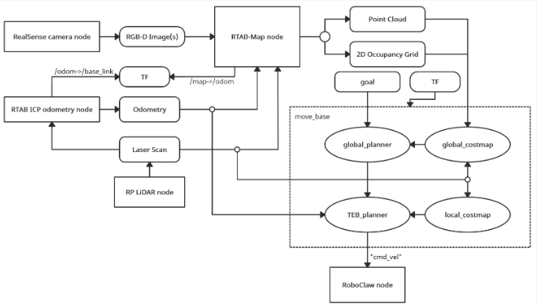

**Fig 16. Organization of ROS nodes in mobile robot ROS network connections**

**Industrial Robot and Setup**

The industrial robot system consists of the ABB IRB 140 robotic arm, dedicated end effector and a corresponding IRC5 controller. The external PC with ROS application is used to instruct the robot arm movements and to integrate the robot arm with the rest of the system. In order for the robot to know where each crate should be placed, an RFID sensor is used to identify each industrial crate. The setup of the industrial robotic arm and its environment was initially designed and simulated in the RobotStudio programming environment. The developed software for simulation was afterwards used to control the real robot.

Within the experiment setup, pallets with crates that the industrial robotic arm needs to sort are placed around the robot. There are six pallets placed around the robot to perform the palletizing task. Four out of six pallets are “output” pallets that should be transferred out after sorting is complete. The “input” pallet with unsorted industrial crates, brought by the mobile robot, is located in front of the robot arm and can contain up to 24 crates. In addition to the “input” pallet, the transitory pallet is set up to temporarily accommodate crates that do not currently have a defined location, as well as crates that have not been successfully identified.

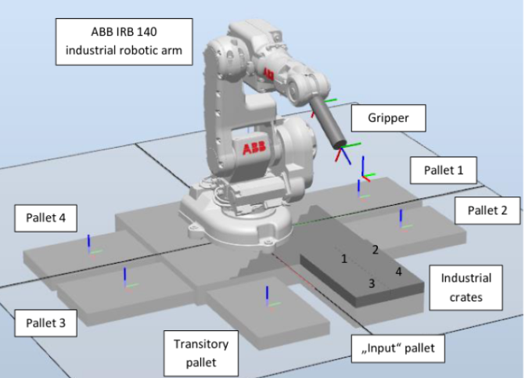

**Fig 17. System setup and the layout in the RobotStudio software environment**

**Software of Industrial Robot**

An increase in the usage of ROS applications in industrial robotics, and its applications on industrial robotic arms, has contributed to the development of the ROS industrial (ROS-I) platform. In addition to the benefits of the standard ROS platform previously mentioned, ROS-I provides us with supplementary tools and capabilities specific to industrial robotic arms. One of the biggest advantages of using the ROS-I platform is the programming of the robotic arm in conventional programming languages, such as Python and C++, instead of the native language of the controller, which is company dependent. The ROS packages used in our work to communicate and control the industrial robot are as follows:

* *abb_driver* that enables the communication between personal computer and ABB IRC5 industrial robot controller for robot control. The messages being exchanged contain information about the condition of the robot, such as the position of the robot’s wrists.
* *aletizer* package, developed for sorting/palletizing industrial crates, as well as to communicate with the rest of the system, e.g., OPIL, from which it receives the commands for palletization and reports on the state of the task.
* *abb_irb140_unal*, the package that provides information about the physical representation of robots, such as URDF and SRDF records.

For controlling the ABB industrial robotic arm, the abb_driver is used (ROS driver for the ABB industrial robots), as the driver is made for specific hardware. The part of the driver located on the industrial controller is written in the programming language RAPID (the native language of the controller), while the part of the driver located on the personal computer is written in C++. The block diagram of communication between two applications/two devices is shown in figure 18.

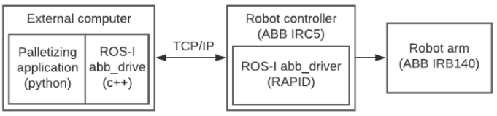

**Fig 18. Block diagram for controlling the ABB IRB 140 robot arm from the ROS application**

Some of the additional features that ROS-I provides in the form of additional packages are an extended set of robotic arm models that the ROS driver can control (abb_experimental package). The experimental package expands the capabilities of the ROS driver and adds the models and parameters of the robotic arms. The most important tool provided using the ROS-I platform is the MoveIt package. The MoveIt package gives us the possibility of creating a functional robot from a CAD model, i.e., generates the required universal robot description format (URDF) and semantic robot description format (SRDF) files to define the parameters of the robotic arm. Additionally, an additional package for a visualization RViz provides us the visualization of 3D models of robots, as well as their movement and coordinate systems.

**Implications and Future Work Directions**

The vibrant landscape of intelligent robotic technology promises to revolutionize vari ous industries and presents numerous opportunities for growth and innovation. This sys tematic literature review explored the impact of robotics and AI on current industry trends, examined existing challenges, identified applications, and assessed the risks and benefits of robotic technology. We provided key implications and future directions to support ongoing research, development, and implementation of intelligent robotic solutions.

In the manufacturing industry, the focus must be on reinforcing the integration of humanskills with automated machines, enhancing human–robot collaboration, and lever aging cloud computing, IoT, big data analysis, and AI for smart manufacturing. As e commerce logistics and automation systems continue to draw from robotics, pertinent challenges relating to cost, accuracy, and collaboration among stakeholders must be ad dressed to bridge potential gaps in efficiency and scalability.

The tourism sector has the potential to further benefit from the integration of robotics and AI technologies by improving customer experiences, service standards, and personal ization. Facial recognition, virtual reality, and other innovative technologies can herald a newera of unique, responsive, and tailored interactions with customers. Additionally, advancements in low-cost robots with computer vision and AI in precision agriculture can revolutionize crop management and introduce new methods for analyzing and addressing plant characteristics.

On going research should also focus on overcoming challenges in areas like open-ended learning, object manipulation, human–robot interaction, and intelligent and collective robots. The development of tools and techniques to address these obstacles will drive progress in various domains, including computer-assisted medicine, educational robotics, and human–machine interaction. Developing ethical frameworks, policy changes, and self-regulation will be essential for mitigating associated risks while maximizing benefits. It is necessary to further understand public perception, employee attitudes, and the impact of this technology on employment and social dynamics.

To improve software engineering practices, human-centric design and interaction remain critical. Advanced sensors, actuators, comprehensive risk assessments, adherence to industry standards, consideration of human affective responses, and learning from industry leaders should be prioritized. In addition, addressing challenges in perception and decision making, improving system architecture, developing testing and simulation processes, and incorporating maintenance practices are key aspects in refining existing robotic technology.

Developing robotic technology that is both ethically and ecologically sustainable is another crucial direction that must be pursued in order to address concerns related to energy consumption, waste disposal, and the environmental impact of robotics [83]. As robotics technology becomes more widespread, investing in long-term sustainability measures will help to ensure future generations can continue leveraging its benefits.

Advancements in communication technologies, such as 5G and beyond, will also play a crucial role in the future of intelligent robotics. Faster, more reliable connectivity will enable robots to make real-time decisions, share large datasets, and facilitate human–robot collaboration more efficiently. As communication technology continues to evolve, the potential applications and capabilities of robotic systems are expected to grow in parallel.

Robotics for disaster management and relief operations is another area that merits more attention. With advancements in robotic technology, partnering robots with first responders can facilitate timely interventions, reducing casualties and providing aid in hazardous or inaccessible environments. Developing and refining advanced search and rescue robots, decontamination robots, and robot-assisted rehabilitation technology will play a critical role in disaster response efforts and healthcare.

Finally, exploring the use of robotics for exploratory missions in extreme environments, such as outer space, deep-sea exploration, and hazardous industrial settings, presents yet another promising avenue for future research and development. Collaborative efforts between stakeholders, such as space agencies, research institutions, and private industries, will undoubtedly drive the creation of innovative robotic solutions designed specifically to operate under the most challenging conditions.

The results of this systematic literature review provide valuable insights for researchers, policymakers, and practitioners in the field of robotics. For researchers, this review identifies key areas in which research efforts should be focused, including improving human robot interaction, advancing open-ended learning, and developing sustainable and ethical technology. Researchers can also draw upon the identified applications, risks, and benefits of robotic technology to inform their work and decision making.

Policymakers stand to gain significant insights from our findings, as well. Under standing the current landscape, challenges, and risks associated with the integration of robotics and AI into various sectors will enable the development of informed policies and regulations. By fostering a safe and ethical environment for the growth and implementation of robotic technology, policymakers can maximize the benefits of this technology while minimizing negative impacts on society, such as employment and social change concerns.

Practitioners, including industry professionals and business leaders, can also benefit from the knowledge gained in this research. Identifying emerging trends and challenges in the realm of robotics and AI will enable informed decision making regarding the adoption and integration of these technologies into existing infrastructure and operations. Furthermore, our review highlights the importance of collaborative efforts between stakeholders, making it clear that cooperation between research institutions, private industries, and governmental bodies is paramount for unlocking the full potential of intelligent robotic solutions.

The implications of this research are diverse, and future work directions can be pursued to further enhance and advance the field of robotics. Here are some key future work directions:

1. **Ethical considerations:** The ethical implications of robotic technology are complex and multifaceted. Future research should continue to delve into the ethical considerations surrounding the use of robotics, including the development of ethical frameworks, addressing privacy concerns, and ensuring responsible and fair use.
2. **Human–robot collaboration:** Exploring ways to improve human–robot collaboration will be crucial in various industries. Future research should focus on developing advancedalgorithmsandtechnologiesthatenableseamlessandeffectivecollaboration between humans and robots, emphasizing safety, reliability, and efficiency.
3. **Sustainability and environmental impact:** As the field of robotics continues to grow, it is important to consider the environmental impact of these technologies. Future research should focus on developing sustainable robotic solutions, including energy efficient designs, recyclable materials, and waste management strategies.
4. **Interdisciplinary research:** The field of robotics encompasses various disciplines, including computer science, engineering, psychology, and social sciences. Future research should encourage interdisciplinary collaboration to address complex challenges and ensure a holistic approach to robotics development.
5. **User experience and acceptability:** Understanding user perceptions, attitudes, and acceptance of robotic technology is crucial for successful implementation. Future research should focus on user-centered design and evaluation, incorporating user feedback and preferences to create robotic solutions that are intuitive, user-friendly, and meet the needs and expectations of end-users.
6. **Regulation and policy:** With the rapid advancement of robotic technology, there is a need for effective regulation and policy frameworks. Future research should explore the legal and regulatory implications of robotics, including liability, safety standards, and privacy regulations, to ensure responsible and ethical use of these technologies.
7. **Integration of emerging technologies:** The integration of robotic technology with emerging technologies such as artificial intelligence, machine learning, blockchain, and 5G can greatly enhance the capabilities and applications of robotics. Future research should focus on exploring the synergies between these technologies and developing novel approaches that leverage their combined potential.
8. **Education and training:** As the field of robotics continues to expand, there will be a growing need for skilled professionals who can design, develop, and maintain robotic systems. Future research should focus on developing educational programs and training initiatives that equip individuals with the necessary skills and knowledge to thrive in the robotics industry.

By addressing these issues, the field of intelligent robotics can continue to evolve and innovate, unlocking new opportunities and addressing the challenges of tomorrow.

**Conclusion**

This systematic literature review provided insights into emerging technologies, trends, challenges, applications, risks, and benefits within the fieldofintelligent robotics. These tech nological innovations have led to significant improvements in efficiency, productivity, and customer experiences across various industries, including manufacturing, logistics, tourism, agriculture, healthcare, education, construction, and more. Furthermore, they are projected to play an even more transformative role in enhancing various aspects of human life and industries in the future.

In addition to these remarkable advancements, the industry still faces critical open research questions that need to be addressed to ensure the responsible and effective inte gration of robotic technology across various sectors. These questions encompass ethical concerns, public acceptance, environmental impact, collaboration, regulation, integration with emerging technologies, education and training, user-centered design, interdisciplinary collaboration, and social and employment implications.

Addressing these open research questions is a crucial step in ensuring the responsible and beneficial integration of intelligent robotics into various sectors. For instance, ethical concerns and public acceptance are essential in fostering trust and ensuring the responsible use of technology. Collaboration between humans and robots requires an understanding of the optimal methods for effective collaboration, ensuring that users understand how to use the technology and ensuring user-centered designs that meet different end-user needs. In regulating the use of robotic technology, policymakers need to understand the implications and develop frameworks that prioritize safety, liability, and privacy concerns. Finally, interdisciplinary collaboration is essential in addressing complex challenges and ensuring a holistic approach to developing robotic systems that benefit various sectors.

Despite the systematic approach employed in this literature review, some limitations were encountered that could have impacted the completeness of the findings. One limi tation was the availability of relevant literature, which could have limited the scope and generalizability of the review. Moreover, the restriction to only studies published in the English language may have introduced language bias, potentially omitting other relevant studies published in other languages. The review’s time limitation is also worth noting, as conducting a comprehensive systematic literature review requires significant time and resources, and thus, newer studies that could have added value to the review were possibly missed. Future research could overcome these limitations by conducting more extensive reviews, incorporating a broader range of databases, and potentially including studies published in other languages.

This report examined the evidence on the current state of service-sector automation of European Union, by surveying of the limited available sources of data on the prevalence of service robots. Among these, the Eurostat ICT Community Survey presents the best cross-country evidence on the prevalence of service robots in Europe. Only around 2% of companies in the European Union report using service robots. By comparison, around 5% of them report using industrial robots. At the moment, service robots are concentrated in a few sectors and applications. The leading use cases are warehouse management for logistics in wholesale and retail trade and transport, inspection and maintenance, and cleaning. The survey has a number of limitations that limit the scope for combining its results with other administrative sources: it uses an expansive interpretation of service robot that overlaps with industrial robots; it only reports the approximate share of companies using them in broad economic sectors and size group; and only accounts for a few possible use-cases of the robots. Finally, the survey only offers a limited snapshot from the year 2018, as the questions on robotics were part of an optional module of the survey, and not all Member States collected these statistics. The module is being re-implemented as a compulsory section in 2020 at the time of writing, with an updated definition of service robot. The results for 2020 will provide better cross-country coverage, and will hopefully allow to see trends in the diffusion of service robots over the last couple of years.

A better sense of what existing service robots can actually do, and what they look like, comes from the World Robotics–Services survey by the International Federation of Robotics. The document presents aggregate sales data coming from around 750 companies producing sales robots. Starting from the definition of service robot developed by the International Organisation for Standardisation, it uses a rich classification of around 60 areas of application for service robots developed jointly by the IFR and the UN Economic Commission for Europe. The global aggregate sales data collected in the IFR report cannot tell us much on the geographic prevalence or distribution of service robots, but the sales volumes of different types of robots by application show the relative development and diffusion of specific technologies. The leading application of service robots is again in logistics systems, covering around 40% of sales of professional service robots. These are often sold as a bundle of robots, the necessary infrastructure, and consulting and maintenance services, and range in shape from autonomous guided vehicles, to mechanical arms for picking items, or a combination of both. Inspection and maintenance robots make up a similarly sized market, which spans a wide range of robots with sensors and cleaning capabilities for cleaning anything from fuel tanks, to machinery and ships hulls. Robots for logistics, together with those for inspection and maintenance, jointly account for nearly 80% of service robot units sold. This is no surprise, considering that the tasks that they seek to automate fit with the historical trend of robots being used first for tasks traditionally described as “dull, dirty, and dangerous” in industry parlance. The COVID-19 pandemic has underscored the importance several essential sectors, including health care and logistics. At the same time, it has shown how workers in those sectors, in every occupation, are frequently exposed to health risks, which derive in part from the way their work is organised. Developments in service robotics will doubtless attempt to address these risks, for instance by limiting the need for physical proximity between humans, or by making cleaning easier and more effective.

Overall, based on the data presented in this report, we can conclude that automation in the service sector – in the form of service robots – is small but growing. Despite the image that the industry projects, currently there are very few consumer-facing humanoid robots in active use. Indeed, leading areas of application for service robots are mostly specialised machinery used behind the scenes in manufacturing-adjacent parts of the service sector, covering logistics, inspection and maintenance, and cleaning. Ultimately, the measure of success of service robots is whether companies actually adopt them over the long run. By that metric, only these few areas of application mentioned above count as successful. Indeed, based on the current state of technology, we can expect increased automation in those service sectors where work is standardised – or can be reorganised in this way – but we expect slower diffusion into other areas of services that involve more interaction with humans.